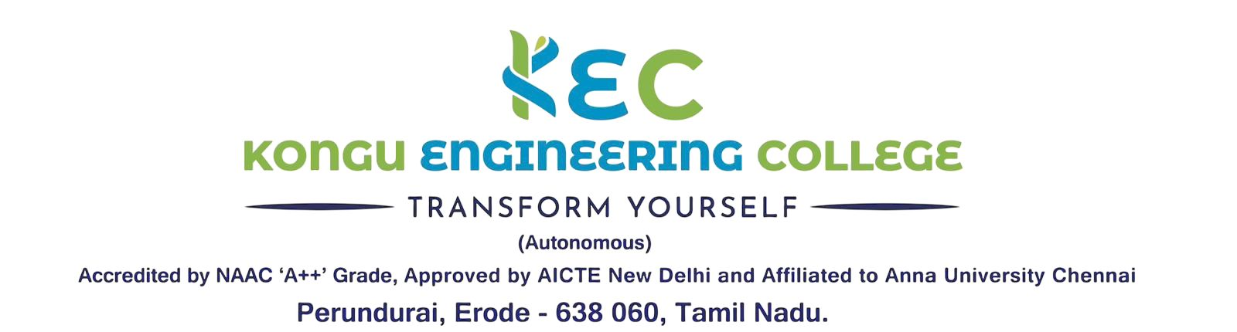 | Doc. No:  KEC/EOMS/MDI/09
 | Rev. No | 00
INTERNAL QUALITY ASSURANCE CELL | Rev. Date | 01.01.2026
QUALITY PLAN | Issue. No | 00

S. No | Criteria | Key Indicators | Measurement | Acceptance level
1. | Student Enrollment and Progression of Students | Students Enrollment  UG/PG | Enrolment Ratio = No. of seats filled / No of Seats Approved | 90 % / program
 |  | Students Enrollment  Ph.D. | No of new students enrolled for the doctoral program | 02/year / per program
 |  | Diversity of Students | Students admitted from other States /International | 5% / program
 |  | Percentage of placement of outgoing students | Percentage of placement based on approved intake | 70%
 |  | Capacity development and skills enhancement initiatives | Programmes conducted  Students benefited | 1/Dept.  All Students
 |  | Percentage of students who have progressed to higher education | Students Joined | 5%
 |  | Percentage of students qualifying in state/ national/ international level examinations | Students qualified in exams like GATE, TOFEL, ILETS, TANCET etc. | 5%
 |  | Guidance for competitive examinations | Programmes conducted  Students benefited | 1/Dept.  20% of Students
 |  | Entrepreneurship | No of startups/Dept. | 1/ intake
 |  |  | No of students attended trainings / Dept. | 10% of Students
 |  | VAC / One credit / 2 credit courses offered | No of courses / department /year | 1 / intake
 |  | Innovative projects development by students | No of projects developed / department / Academic Year  No of projects presentation/ student/ Academic Year (through IIC/IEF) | 2  2
 |  | Participation of students in Co/Extra-curricular activities | No of events Participation / student/ Semester | 2
 |  | Paper presentation by students | Premier Institutions Minimum presentation/ student during entire course of study | 1
 |  |  | Other Institutions Minimum presentation/ student / Academic Year | 1
 |  |  | Within institution Minimum presentation/ student/ Academic Year | 1
 |  | Industrial visits by students | No of visits during entire course of study | 2
 |  | In-plant Training | No of 5 days training during entire course of study / student | 1
 |  | Association / Chapter activities  (Clubs may plan 50 % activity exclusive) | Minimum Membership/ student | 1
 |  |  | Membership by students in societies /clubs | 1
 |  |  | No of Association activities/ Academic Year | 8
 |  |  | No of Lectures by Industry personnel/ eminent people/ Academic Year | 4
 |  |  | No of alumni Lecture/ Academic Year | 4
 |  |  | No of National event like symposium/ Academic Year | 1
 |  |  | No of News Letter / semester | 2
 |  |  | No of Intra dept. event like Symposium/ Academic Year | 1
2 | Research | Number of quality publications in refereed/SCI Journals, citations, Books/Book Chapters etc. | SCI Faculty / dept  SCOPUS  Faculty / dept  Others Faculty / non engg dept  Minimum no of citations Faculty / dept/  Academic Year | 50%  100%  50%  5
 |  | PhD awarded | No of candidates/Year | 1
 |  | Project to Paper Conversion | UG Scopus  PG Scopus Journal  SCI Journal | 100%  50%  50 %
 |  | Funded research from outside | Govt agencies | 15 Lakhs on going/dept
 |  | No of R and D proposals to be submitted |  | 1/ faculty
 |  | Consultancy (From Industry) | Only consultancy / intake  Academic Year | 1 Lakh
 |  | Consultancy (testing and Others) | Testing / corporate training Courses/ intake/ Academic Year | 1 Lakh
 |  | Patents Published and Granted | Applied / intake /Academic Year  Published/ intake /2 Academic Years | 1  1
 |  | Workshops/seminars conducted on Research Methodology, Intellectual Property Rights (IPR) | No of Programmes / Department/Academic Year  No of Faculty benefited/Academic Year  No of Students benefited/Academic Year | 1  50 % Faculty  25% Students
 |  | Number of Collaborative activities per year for research | No of Faculty Initiated / Department/Academic Year | 10 %
 |  | Number of functional MoUs with institutions | No of new MoUs/ Department/Academic Year  No of activities / Department/Academic Year | 1  2
3 | Teaching Leaning | Innovative Teaching Methods OBTL(OBE) initiatives such as real life examples, design thinking/case study, Collaborative Learning, Practical oriented learning etc | Planned in Lecture plan and its compliance per course | 1
 |  | Developing e-content to encourage self-learning aspects | Developing materials and assessment tools / You tube Videos etc through ICT tools | 1
 |  | Virtual Lab Experiments /  Mini project based experiments | Experiments per course for 2 and 3 years | 1
 |  | Micro projects in Theory Courses | Simulation / Project based Assessment for tutorials for 2 and 3 years / Semester | 1
 |  | Field visits for courses | One day factory visits for Theory courses for self-learning in 2 and 3 year of study / dept. | 50%
 |  | Assessment and Evaluation activities | CAT: Percentage of Pass in each course | 80 % Theory  75%Analytical
 |  |  | ESE : Percentage of Pass in each course | 90 % Theory  85%Analytical
 |  |  | Remedial Sessions based on CAT Pass % deviation / CMC feedback (if) hours/course | 2
 |  |  | Remedial Sessions based on ESE Pass % deviation(if) hours/course | 5
 |  |  | Laboratory: Continuous Evaluation of Records/ Manuals/CAT | 3
 |  |  | CCC Meetings for courses | 4 Theory  3 Lab
 |  |  | Attendance percentage per course | As per regulation
 |  |  | Overall Attendance percentage
4 | Continuous Improvements | Students | Feed back in CMC | 3/ semester
 |  |  | Course End Survey (Theory/Lab/Project/VAC) / Semester for All core and PE courses | 1
 |  |  | Feedback about the teacher/ Semester for All courses | 1
 |  |  | Feedback for design and review of syllabus/ Semester for All courses | 1
 |  |  | About Facilities/ Year from All students /Year | 1
 |  | Alumni | Graduate Exit survey for PO & PSOs at the end of the programme | 1
 |  |  | Feedback for design and review of Curriculum end of the programme | 1
 |  | Parents | About programme and facilities / Semester | 1
 |  | Employers | Feedback for design and review of Curriculum /Academic Year | 1
 |  |  | Feedback for PO & PSOs for all batches/Academic Year | 1
 |  | Teachers | Feedback for design and review of course for All courses /Semester | 1
 |  |  | Feedback for design and review of Curriculum /Academic Year | 1
5 | Examinations | Continuous Assessments and End Semester Examinations | Theory, Laboratory, Programming, VAC courses | As per regulations
6 | Human Resource | Faculty | Student Faculty Ratio Engg Dept.  Applied Science  S & H  MBA
 |  |  | Cadre Ratio | 1:2:6
 |  |  | No of Ph. D. | 30%
 |  |  | Retention | 75 %
 |  |  | Training attended by faculty members  (STTP/ FDP/NPTEL,etc. & industrial training) (minimum 5 days) /Faculty /Academic Year | 1
 |  |  | Conferences attended by the each faculty /Academic Year | 1
 |  |  | Knowledge transfer activities outside by Faculty / department /Academic Year | 25 %
 |  |  | Research laboratories visits like DRDO, CSIR, IITs, IISc, CDAC, Industrial research Centre etc. by Faculty / department /Academic Year | 5 %
 |  |  | Developmental activities / department /Academic Year  Product Development (IIC, TBI, etc) | 10 %
 |  | Staff | Skill up-gradation training /Staff / Academic Year | 50 %
7 | Budget Allocation & Utilization | Program Specific Budget | Budget Utilization against Sectioned | 80%
 |  | Industry Sponsored labs | Financed by Industry/ department/ 3 years | 1
 |  | Centre of Excellence and revenue generated | Revenue generated / Centre / Academic Year | 50,000/-
8 | Others | No of new books added Library | Institute / Academic Year | As per AICTE norms
 |  | No of e-resources and Digital Library | Institute / Academic Year
 |  | Availability of Computers and Printers | Department

